1. I’m really indecisive… Well, no I’m not. Actually, I am. Anyway, I need you to make some basic decisions for me because I’m having trouble trying to plan my day:

* OPTIONAL: Read up on the types of control flow
* Create a new application. Make a Launcher class with a main method
* Instantiate a **String array** that holds a String for each day of the week.
  + {“Monday”, “Tuesday”, etc.}
* Use a **for loop** to iterate through the array and print the day of the week out.
* Within the for loop, after printing the day of the week out, use an **if/else statement** (or something else if you want) to determine if the day of the week starts with a “T” or “S”.
  + If it does, print out “go to the gym”. Otherwise, print “stay home”

Coding questions are often kind of vague… try to focus on what exactly is being asked. To solve this, you need an array, which you loop through with a for loop, which has a print statement and an if/else statement that prints one thing or another. You also need to know how to get the first CHARacter of a String. There are a few ways to find the first character of a String. Could there be a String method to do so? Hmmm… Good luck :)

Also remember the char data type uses ‘single quotes’, not “double quotes”. Why am I telling you this? IDK ;)

Your output should look something like this:

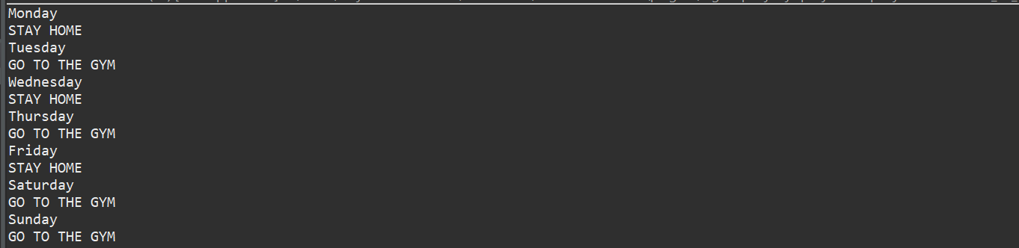

1. Switch statements are often used when the only other option is a million if/else if/elses. Your task is to create a simple user interface menu using a while loop, a switch, and Scanner.

* Initialize a boolean called displayMenu. Set it equal to true.
* Initialize a scanner object, which you’ll use to take in user input.
* Create a while loop that evaluates the value of displayMenu
* Inside the while loop, print out “Make a choice:” or something similar.
* Use your scanner from above to take in user input and save it as a String.
* Finally, create a switch case on that user’s input! The switch should have 3 cases and one default:
  + **Case 1**: If the user enters “hello”, print out a greeting to the console.
  + **Case 2**: If the user enters “sing”, print out the lyrics to a good song.
  + **Case 3**: If the user enters “goodbye”, print out a goodbye message and assign displayMenu = false. This should break the while loop.
  + **Default**: If the user’s input matches none of the cases, print out “input not recognized - try again!”
* So now, you should have a while loop based menu that continuously tells the user to enter values. Based on the user’s input, it either performs some task and loops again (case 1,2 and default), or performs some task and exits (case 3).
  + Not very polished though… You can try making it more user friendly. For instance, the user doesn’t see their options in the console during runtime. A visible menu would be a nice touch to add.

Here’s an example of some valid switch syntax to help you out. Note it’s using an int, and not a String.

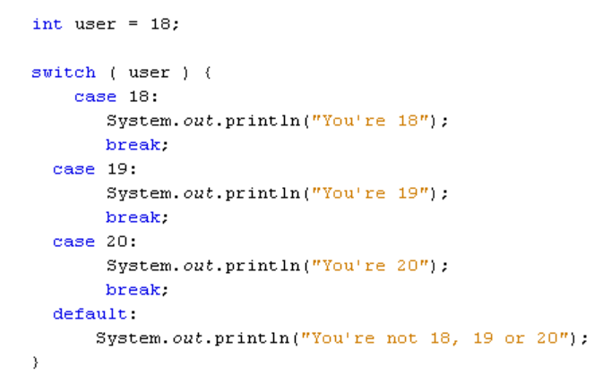

*Add your break statements! Every case after the matching case will run if you don’t add them.